Chapter 6, Problem 82.

Design an an op amp circuit such that:

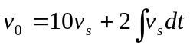

where v_{s} and v₀ are the input voltage and output voltage respectively.

